G VENKATA SRIDHAR  gvsridhar.devops@gmail.com
+91-9739964629

ANSIBLE
What is Ansible?
- Ansible is a configuration management system used to set up and manage infrastructure and applications in varied environments. It allows users to deploy and update applications in approachable language, using SSH, without needing to install an agent on a remote system.
- Ansible is an IT automation engine that automates provisioning, configuration, application deployment and many it other needs.
- It is maintained by RedHat. Free and open source.
- Ansible is a configuration management and application deployment, Task automation and it orchestion.

Features of Ansible?
- It is free and open source
- Highly scalable (you can control 10 clients and you can control 1000 clients)
- Agent less client configuration (no need to install agent in Ansible)
- Written in python, so it is easy to read and write.
- Ansible uses YAML syntax in configuration file.

Requirement of Ansible?
- SSH Client (OpenSSH)
- Python

Components of Ansible?
Programs
  - Ansible
  - Ansible-doc
  - Ansible-playbook
  - Ansible-pull
Modules
  - It has set of instructions written for one particular service type
  - Some of the examples are Copy Module, Service Module, and User & Group.

How to install Ansible in RHEL (LINUX)?
- rpm -Uvh https://dl.fedoraproject.org/pub/epel/epel-release-latest-7.noarch.rpm
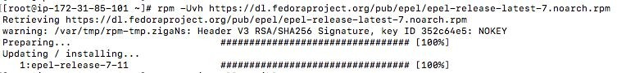

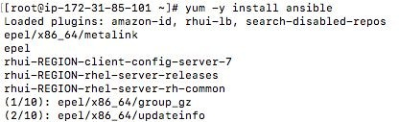
- yum -y install ansible

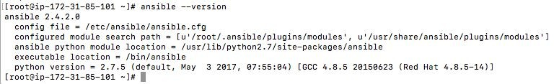

(Or)

PIP
- You can also install Ansible using a Python package manager like PIP. For installing ansible-using pip, ensure pip is installed on your system. If not, please install it using your distro’s package manager or esay_install. Once done, you can use pip to install Ansible:

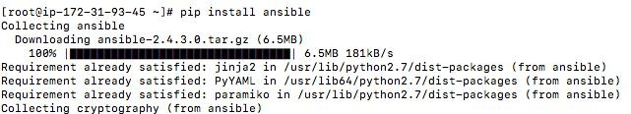
Sudo yum update

GIT
- You can also clone the Ansible repository and install it from source. Before installing ansible from GIT, make sure pip and additional python related dependencies are installed. Then, you can install Ansible from source:

- git clone git://github.com/ansible/ansible.git –recursive
- cd ./ansible
- source ./hacking/env-setup

Ansible Terminology?
How to setup SSH key Remote Host?
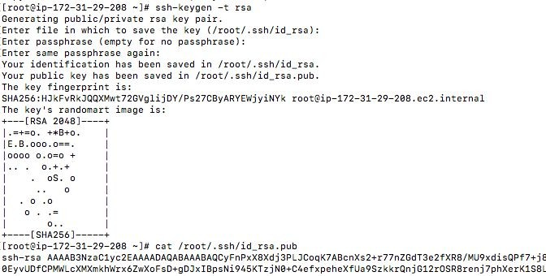
Step 1: Generate the SSH Key by using below command.

Step 2: Id_rsa.pub key is copy and paste into the Remote host .ssh folder under one of their authorized_keys.

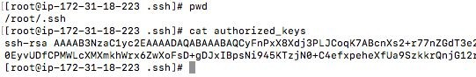
Step 3: This is remote server login:

What is Ad-Hoc?
  - An ad-hoc command is something that you might type in to do something quick, but do not want to save for later.
  - Refers to running Ansible to perform some quick command, using /usr/bin/ansible, rather than the orchestration language, which is /usr/bin/ansible-playbook. An example of an ad hoc command might be rebooting 50 machines in your infrastructure. Anything you can do ad-hoc can be accomplished by writing a playbook and playbooks can glue many other operations together.
  - Ad-Hoc command can be used to simple quick task to perform some simple operations command line itself.
  - Really, automation work using play books only.
  - If play book is real automation why do use ad-hoc command / you may not need to perform a big operations, some time we required to some simple task you don't need to write a play books for everything also it is easiest way.

Example: If you want to install http server, you are required to do multiple tasks, it's like installing a http package, then you have to configure the package, then you have to start the service so for this kind OS multiple tasks
Write a playbook and execute it. Even you do the same task by using ad-hoc command but for each task, you need to run command manually.

ad-hoc command syntax:
- command hostgroupname modules/arguments [options]
Example: ansible all reboot/ping (or) ansible all -a uptime

Ansible Commands:
  - All servers ping in appgroup - [root@ip-172-31-16-74 ansible] # ansible appgroup -m ping
-m means modules
  - All servers ping in ansible - [root@ip-172-31-16-74 ansible] # ansible all -m ping
  - It will display output in single line - [root@ip-172-31-16-74 ansible] # ansible all -m ping -o
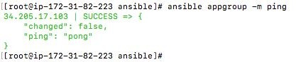
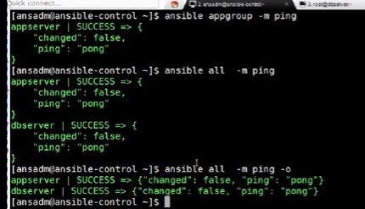
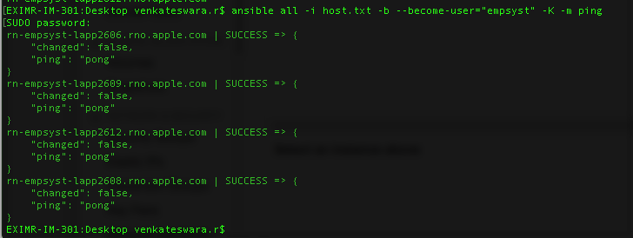
  - My company using this command by ping - [root@ip-172-31-16-74 ansible] # ansible all -i hosts.txt -b --become-user="empsysp" -K -m ping
- “-a” can specify particular command witch you want to run - [root@ip-172-31-16-74 ansible] # ansible all -m shell -a "uname -a;df -h"

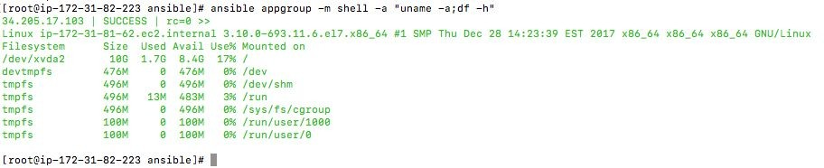

-v means verbose
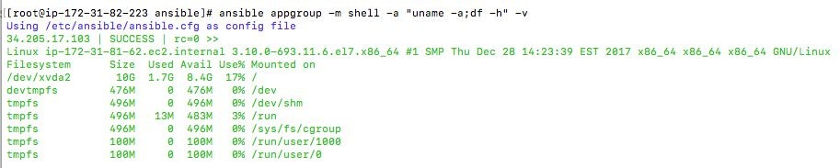
-s means use sudo on the client system

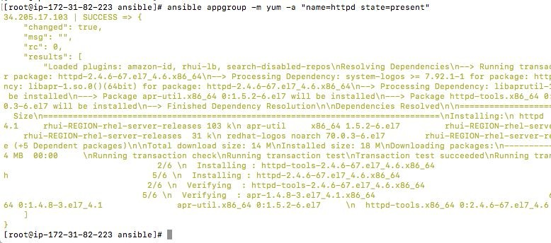
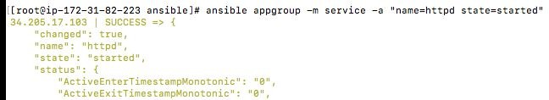
Install httpd server by using ansible ad-hoc command

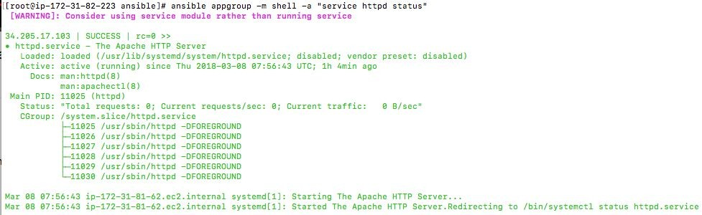
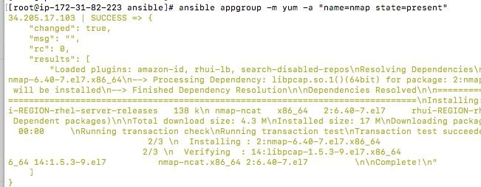
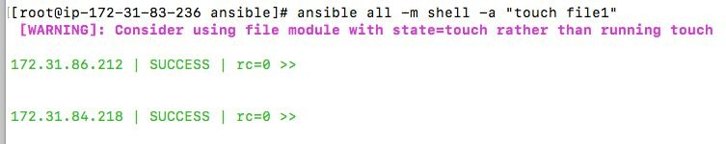
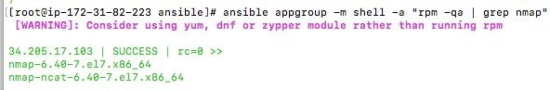

To find out packages is installed or not
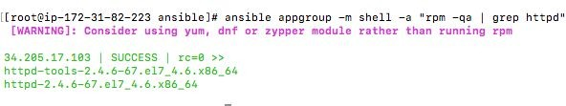

What is Inventory file in Ansible?
  - An inventory file is the source of truth for Ansible. It follows the INI format and tells Ansible whether the remote host or hosts provided by the user are genuine or not.
  - You can pass the inventory file to Ansible using the -i or --inventory-file option followed by the path to the file. If you do not explicitly specify any inventory file to Ansible, it will take the default path from the host_file parameter of ansible.cfg, which defaults to /etc/ansible/hosts

INI, which stands for "initialization"?
- The INI file format is an informal standard for configuration files for some platforms or software. INI files are simple text files with a basic structure composed of sections, properties, and values

What is PlayBook?
- Playbooks are Ansible’s configuration, deployment, and orchestration language. They can describe a policy you want your remote systems to enforce, or a set of steps in a general IT process.
- If Ansible modules are the tools in your workshop, playbooks are your instruction manuals, and your inventory of hosts are your raw material.
  - PlayBook exists to run task
  - Tasks is a list of task
  - Action is a part of task that specify witch of the modules to run and witch arguments to pass to that module
  - Each task is have only one action.
  - [ ] → It specify groups

  - All configuration files is saved in cat /etc/hosts/

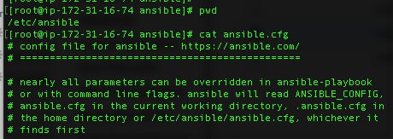

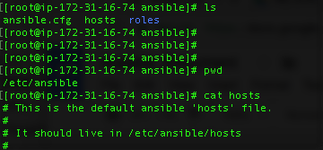
- All the remote hosts are saved in path:
https://www.youtube.com/watch?v=ChSCEXQHfI4&list=PLLsor6GJ_BEEC9jUSc76 0iqaOx6u5lqRA&index=2 https://www.digitalocean.com/community/tutorials/how-to-install-and-configur e-ansible-on-centos-7 https://www.youtube.com/watch?v=kyS_AP0XHyU&list=PLYliwzTugkt0psp7rxCv C_4Cqdk3lvbHy

EXIMR-IM-301: tasks venkateswara.r$ cat main.yml
========================================
- name: check profile
shell: rpm -q oel-config-yumrepo | cut -d '-' -f 5 register: current_profile

- meta: end_play
when: current_profile.stdout == "{{ patch_snap }}.noarch"

- name: check if application running
shell: if ps -eaf | egrep 'java|apache|httpd|stunnel' | grep -v grep > /dev/null;
then echo 'process running'; else echo 'process not running';fi
register: app_process_check

- name: decision point to start patching
debug: msg="{{ inventory_hostname }} have running application.
Please stop the application first, and then attempt patching."
when: app_process_check.stdout == "process running"

- name: copy checkprocess script
copy: src=checkprocess.sh dest="/ngs/app/{{ app_user }}" mode=755

- name: list of java process running
command: sh checkprocess.sh chdir="/ngs/app/{{ app_user }}" register: java_process_path
ignore_errors: True
- debug: msg={{ java_process_path.stdout }}

- name: check for java process shell: ps -Al | grep -c java register: is_java_process ignore_errors: True
- debug: msg="{{ is_java_process.stdout }} java process running"

- name: check for httpd process shell: pidof httpd
register: is_httpd_process ignore_errors: True
- debug: msg={{ is_httpd_process.stdout }}

- name: check for stunnel process shell: pidof stunnel
register: is_stunnel_process ignore_errors: True
- debug: msg={{ is_stunnel_process.stdout }}

- name: Execute the jetty stop script
action: shell pkill -IO -f {{ artifact_name }} || true
when: (is_java_process.stdout != "") and (( servertype == "jetty"))
ignore_errors: True

- name: Execute the jboss | custom | coherence stop script #
action: shell pkill -IO -f {{ deployable }} || true
when: (is_java_process.stdout != "") and ((servertype == "jboss7") or (servertype = "jboss5")
or (servertype == "coherence") or (servertype == "custom"))
ignore_errors: True

- name: Execute the stop script shell: killall java
when: is_java_process.stdout != 0 ignore_errors: True

- name: stop the stunnel process shell: killall stunnel
when: is_stunnel_process.stdout != "" ignore_errors: True

- name: stop the httpd process
shell: sudo service apple-apache2 stop when: is_httpd_process.stdout != ""
ignore_errors: True

- name: trigger update_me
command: sudo /ngs/global/bin/update_me -d {{ patch_snap }} --crno {{ crno }} --batch -w 5
override-monsoon
when: current_profile.stdout != "{{ patch_snap }}.noarch"

- name: Wait 50 seconds, but only start checking after 40 seconds wait_for_connection:
delay: 40
timeout: 50

- name: check cleanup
command: grep "update_me --cleanup" /etc/motd register: is_cleanup
ignore_errors: True

- name: trigger cleanup
command: sudo /ngs/global/bin/update_me -k --batch when: is_cleanup|succeeded

- name: start apache
shell: sudo service apple-apache2 start
when: is_httpd_process.stdout != ""
ignore_errors: True

- name: start stunnel
shell: ./stunnel stunnel.conf;chdir="/ngs/ap/{{ app_user }}/stunnel" when: is_stunnel_process.stdout != ""
ignore_errors: True

- name: display the upgraded OS version
shell: rpm -q oel-config-yumrepo | cut -d '-' -f 5
register: OSVersion
debug: msg={{ OSVersion.stdout }}

- name: copy startjavaapp script
copy: src=startjavaapp.sh dest="/ngs/app/{{ app_user }}" mode=755

- name: execute java process jboss 7 and 5 | coherence
command: sh startjavaapp.sh {{ deployable }} {{ servertype }} {{ java_process_path.stdout }}
{{ app_user }} {{ is_java_process.stdout }} chdir="/ngs/app/{{ app_user }}"
when: (is_java_process.stdout != 0) and ((servertype == "jboss7") or
(servertype == "jboss5") or (servertype == "coherence") or (servertype == "custom"))
ignore_errors: True
debug: msg="{{ java_process_path.stdout }} == {{ deployable }} == {{ servertype }}"

- name: execute java process jetty
command: sh startjavaapp.sh {{ artifact_name }} {{ servertype }} {{ java_process_path }}
{{ app_user }} {{ is_java_process.stdout }} chdir="/ngs/app/{{ app_user }}"
when: (is_java_process.stdout != 0) and (( servertype == "jetty")) ignore_errors: True

- name: delete checkprocess file
file:
path: "/ngs/app/{{ app_user }}/checkprocess.sh"
state: absent

- name: delete startjavaapp file file:
path: "/ngs/app/{{ app_user }}/startjavaapp.sh"
state: absent

EXIMR-IM-301: tasks venkateswara.r$
==============================

